**COMPARC PROJECT**

**Program:** Computes for sin and cos given the Taylor series formula:

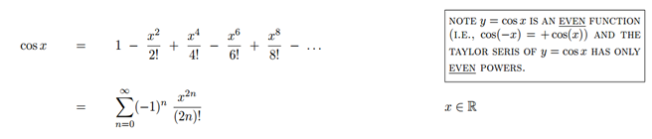

**Input:** First, the program accepts an integer value to as the limit value for the summation. Then program accepts a floating point value x, which is converted to radians (π), before processing the formula above.

**Output:** The program will then output the value of cos x

**I.E.** Cos (0(π)) = 1

Cos (1(π)) = -1